**Practical – 1**

**Aim: -** Recognize the physical topology and cabling (coaxial, OFC, UTP, STP) of a network.

**Physical Topology: -** The arrangement of a network that comprises nodes and connecting lines via sender and receiver is referred to as network topology.

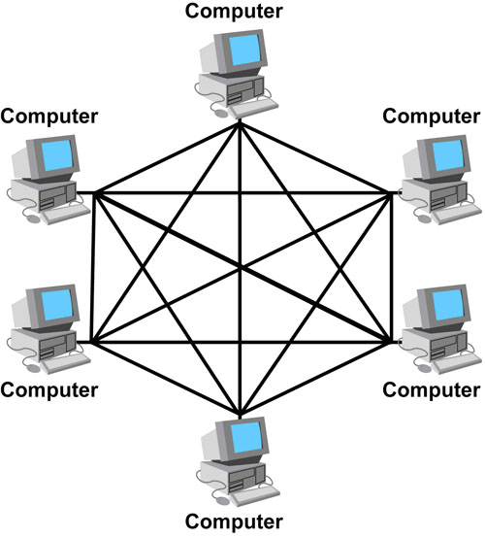**Types of Topology: -**

1. **Mesh Topology**

* In a mesh topology, every device is connected to another device via a particular channel.
* There are multiple paths from one computer to another computer.
* Mesh topology is mainly used for wireless networks.
* **Example: -** The Internet is the best example of mesh.

In this **Figure** All this devices are interconnected via a dedicated channels called Links

**Advantage of Mesh Topology: -**

* Reliable
* Fast Communication
* Easier reconfiguration

**Disadvantage of Mesh Topology: -**

* Cost
* Management
* Efficiency

1. **Star Topology**

* In this, all the devices are connected to a single hub through a cable.
* This hub is the central node and all other nodes are connected to the central node.
* Coaxial cable or RJ-45 cables are used to connect the computers.

**Advantage of Star Topology**

* Efficient troubleshooting
* Network Control
* Limited Failure
* Cost Effective

**Disadvantage of Star Topology**

* A Central Point of Failure
* Cable
* Additional devices slow the network down.

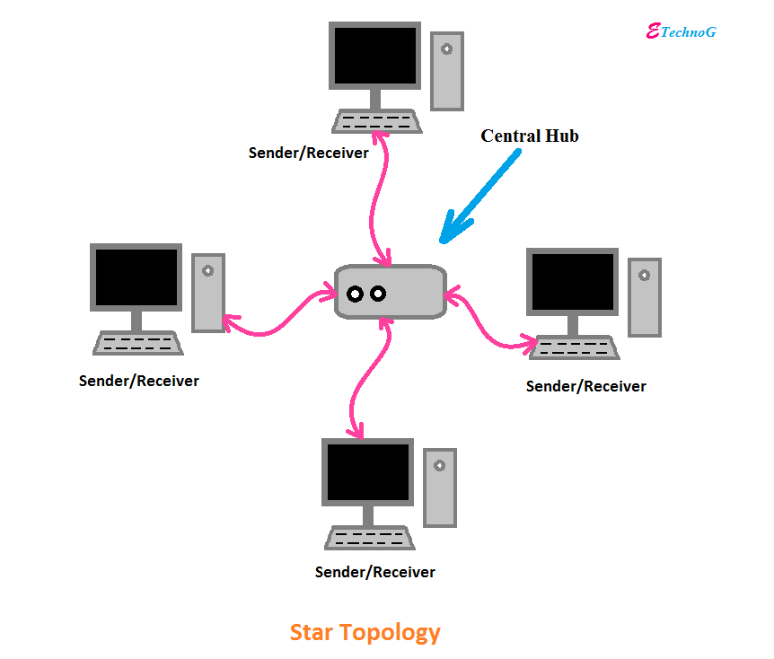

1. **Bus Topology**

* Bus topology is a network type in which every computer and network device is connected to a single cable.
* It transmit the data from one end to another in a single direction.
* No bi-directional feature is in bus topology.
* It is a multi-point connection and a non-robust topology because if the backbone fails the topology crashes.

**Advantage of Bus Topology**

* + Low Cost cable
  + Moderate Data Speed
  + Familiar Technology
  + Limited Failure

**Disadvantage of Bus Topology**

* Extensive Cabling
* Difficult Troubleshooting
* Attenuation
* Signal Interference

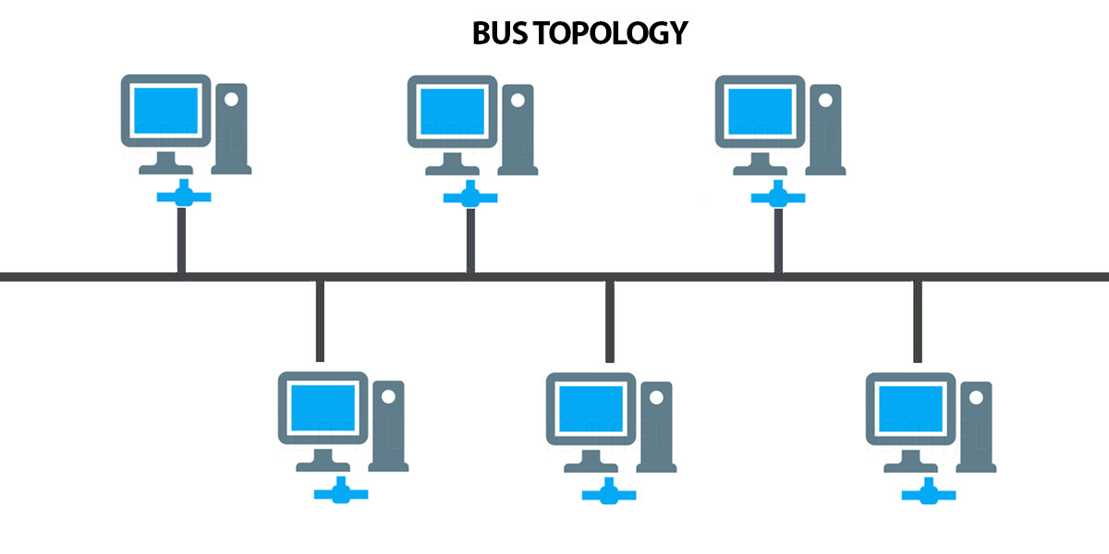

1. **Ring Topology**

* Ring topology is like a bus topology, but with connected ends.
* The node that receives the message from the previous computer will transmit to the next node.
* The data flows in one direction only i.e. uni-directional.
* The data in ring topology flow in a clockwise direction.
* In this, a token is used as a carrier.

**Advantage of Ring Topology**

* Network Management
* Product availability
* Cost
* Reliable

**Disadvantage of Ring Topology**

* Failure
* Difficult troubleshooting
* Delay

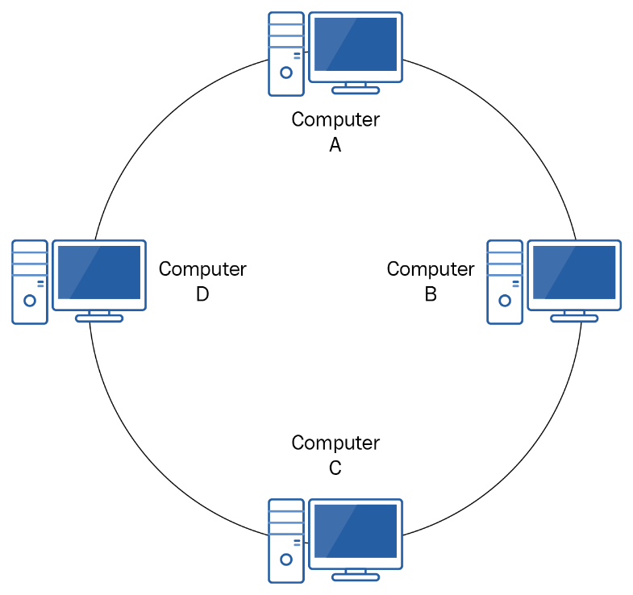

1. **Tree Topology**

* Tree topology combines the characteristics of bus topology and star topology.
* In this all the computers are connected with other in hierarchical manner.
* The top most node is known as root node and all other nodes are descendant of the root node.

**Advantage of Tree Topology**

* Easily expandable.
* Easily manageable.
* Error detection.
* Limited failure.

**Disadvantage of Tree Topology**

* High cost.
* Difficult troubleshooting.
* Failure.

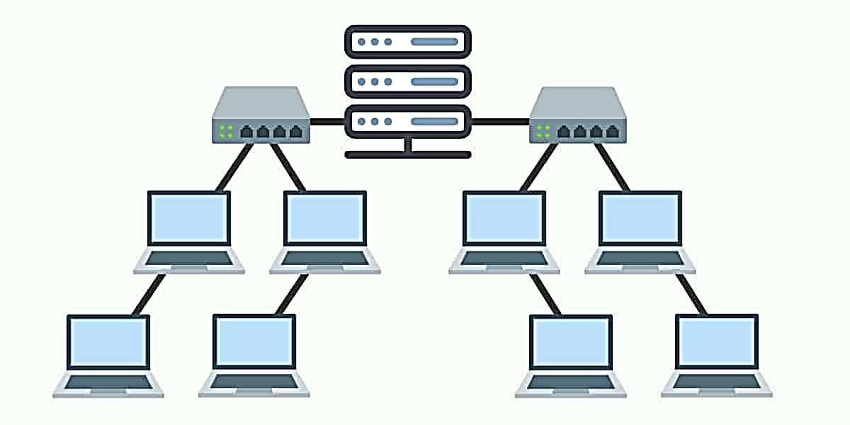

**Cabling (Network)**

Cabling is the set of wires made of either copper or glass that is used to connect computers and other network components to enable them to communicate, thus forming a network of computers.

**Coaxial Cable:-** Coaxial cables, commonly called coax, are copper cables with metal shielding designed to provide immunity against noise and greater bandwidth. Coax can transmit signals over larger distances at a higher speed as compared to twisted pair cables.

**Structure of Coaxial Cable: -** Coaxial has a central core of stiff copper conductor for transmitting signals. This is covered by an insulating material. The insulator is encased by a closely woven braided metal outer conductor that acts as a shield against noise.

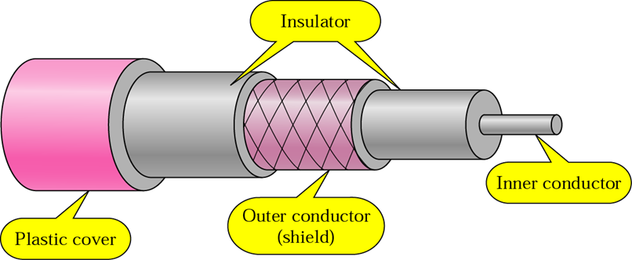

**Optical Fiber: -** An Optical Fiber is a cylindrical fiber of glass which is hair thin size or any transparent dielectric medium. The fiber which is used for optical communication is waveguides made of transparent dielectrics.

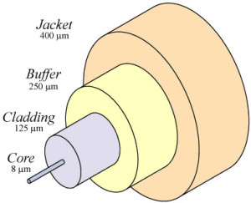

**Main element of Optic Fiber: -**

1. **Core: -** It is the central tube of very thin size made of optically transparent dielectric medium and carries the light transmitter to receiver and the core diameter may vary from about 5um to 100 um.
2. **Cladding: -** It is outer optical material surrounding the core having reflecting index lower than core and cladding helps to keep the light within the core throughout the phenomena of total internal reflection.
3. **Buffer Coating: -** It is a plastic coating that protects the Fiber made of silicon rubber. The typical diameter of the Fiber after the coating is 250-300 um.

**UTP (Unshielded Twisted Pair): -** UTP is an unshielded twisted pair cable used in computer and telecommunications mediums. Its frequency range is suitable for transmitting both data and voice via a UTP cable. Therefore, it is widely used in the telephone, computers, etc. It is a pair of insulated copper wires twisted together to reduce noise generated by external interference. It is a wire with no additional shielding, like aluminium foil, to protect its data from the exterior.

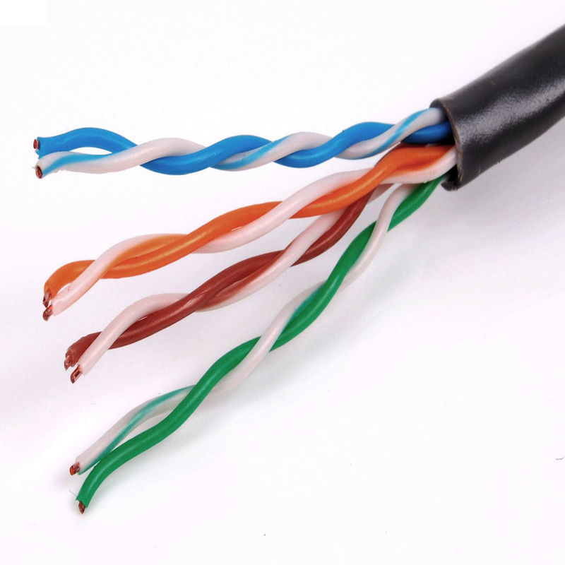

**STP (Shielded twisted pair): -** A shielded twisted pair is a type of twisted pair cable that contains an extra wrapping foil or copper braid jacket to protect the cable from defects like cuts, losing bandwidth, noise, and signal to the interference. It is a cable that is usually used underground, and therefore it is more costly than UTP. It supports higher data transmission rates across the long distance. We can also say it is a cable with metal sheath or coating that surrounds each pair of the insulated conductor to protect the wire from external users and prevent electromagnetic noise.

